Hand Gesture Recognition and Voice Conversion for Deaf and Dumb

INTRODUCTION:
Nowadays we always hear about new technology that improves our lifestyle, that makes our life easier. Technology has revolutionized the human mankind. Human race has put a gear in technology and they are not in a mood to move the pedals away from this gear. There is huge research on various technology sector such as Artificial Intelligence, Smart phones and many more. This research lead to new inventions and making one’s life easier. But there has been a very less research for Deaf and Dumb people. This topic has get less attention as compared to other sectors. The Main challenges that this special person facing is the communication gap between -special person and normal person. Deaf and Dumb people always find difficulties to communicate with normal person. This huge challenge makes them uncomfortable and they feel discriminated in society. Because of miss communication Deaf and Dumb people feel not to communicate and hence they never able to express their feelings. HGRVC (Hand Gesture Recognition and Voice Conversion) system localizes and track the hand gestures of the dumb and deaf people in order to maintain a communication channel with the other people. The detection of hand gestures can be done using web camera. The pictures are then converted into standard size with the help of pre-processing. The aim of this project is to develop a system that can convert the hand gestures into text. The focus of this project is to place the pictures in the database and with database matching the image is converted into text. The detection involves observation of hand movement. The method gives output in text format that helps to reduce the communication gap between deaf-mute and people.
ABSTRACT:
Communication is the main channel between people to communicate with each other. In the recent years, there has been rapid increase in the number of deaf and dumb victims due to birth defects, accidents and oral diseases. Since deaf and dumb people cannot communicate with normal person so they have to depend on some sort of visual communication. There are many languages spoken all around the world and interpreted. “Special people”, that is people who have difficulty in speaking and hearing “The dumb” and “The deaf” people respectively find it difficult to understand what exactly the other person is trying to express and so with the deaf people. Sometimes people interpret these messages wrongly either through sign language or through lip reading or lip sync. This project is made in such a way to help these specially challenged people hold equal par in the society.
LITERATURE SURVEY
Real-time two-way communication approach for hearing impaired and dumb person based on image processing
In the recent years, there has been rapid increase in the number
of deaf and dumb victims due to birth defects, accidents and oral
diseases. Since deaf and dumb people cannot communicate with
normal person so they have to depend on some sort of visual
communication. Gesture shows an expressive movement of body
parts such as physical movements of head, face, arms, hand or
body which convey some message. Gesture recognition is the
mathematical interpretation of a human motion by a computing
device. Sign language provide best communication platform for
the hearing impaired and dumb person to communicate with
normal person. The objective of this research is to develop a real
time system for hand gesture recognition which recognize hand
gestures, features of hands such as peak calculation and angle
calculation and then convert gesture images into voice and vice
versa. To implement this system we use a simple night vision
web-cam with 20 megapixel intensity. The ideas consisted of
designing and implement a system using artificial intelligence,
image processing and data mining concepts to take input as hand
gestures and generate recognizable outputs in the form of text
and voice with 91% accuracy.
In the recent years, there has been rapid increase in the number
of deaf and dumb victims due to birth defects, accidents and oral
diseases. Since deaf and dumb people cannot communicate with
normal person so they have to depend on some sort of visual
communication. Gesture shows an expressive movement of body
parts such as physical movements of head, face, arms, hand or
body which convey some message. Gesture recognition is the
mathematical interpretation of a human motion by a computing
device. Sign language provide best communication platform for
the hearing impaired and dumb person to communicate with
normal person. The objective of this research is to develop a real
time system for hand gesture recognition which recognize hand
gestures, features of hands such as peak calculation and angle
calculation and then convert gesture images into voice and vice
versa. To implement this system we use a simple night vision
web-cam with 20 megapixel intensity. The ideas consisted of
designing and implement a system using artificial intelligence,
image processing and data mining concepts to take input as hand
gestures and generate recognizable outputs in the form of text
and voice with 91% accuracy.
In the recent years, there has been rapid increase in the number of deaf and dumb victims due to birth defects, accidents and oral diseases. Since deaf and dumb people cannot communicate with normal person so they have to depend on some sort of visual communication. Gesture shows an expressive movement of body parts such as physical movements of head, face, arms, hand or body which convey some message. Gesture recognition is the mathematical interpretation of a human motion by a computing device. Sign language provide best communication platform for the hearing impaired and dumb person to communicate with normal person. The objective of this research is to develop a real time system for hand gesture recognition which recognize hand gestures, features of hands such as peak calculation and angle calculation and then convert gesture images into voice and vice versa. To implement this system we use a simple night vision web-cam with 20 megapixel intensity. The ideas consisted of designing and implement a system using artificial intelligence, image processing and data mining concepts to take input as hand gestures and generate recognizable outputs in the form of text and voice with 91% accuracy.
"Computer vision-based approach for Indian Sign Language character recognition."
Deaf and dumb people communicate among themselves using sign languages, but they find it difficult to expose themselves to the outside world. This paper proposes a method to convert the Indian Sign Language (ISL) hand gestures into appropriate text message. In this paper the hand gestures corresponding to ISL English alphabets are captured through a webcam. In the captured frames the hand is segmented and the state of fingers is used to recognize the alphabet. The features such as angle made between fingers, number of fingers that are fully opened, fully closed or semi closed and identification of each finger are used for recognition. Experimentation done for single hand alphabets and the results are summarised.
"AAWAAZ: A communication system for deaf and dumb.”
The paper proposes a framework for recognizing hand gesture which would serve not only as a way of communication between deaf and dumb and mute people, but also, as an instructor. Deaf and dumb individuals lack in proper communication with normal people and find it difficult to properly express themselves. Thus, they are subjected to face many issues in this regard. The sign language is very popular among them and they use it to express themselves. Thus, there is a need of a proper translator. The deaf and dumb are not idle as past, they are working outside and doing great at it. So an efficient system must be set up, to interact with them, to know their views and ideas. The framework here, act as a communication system for deaf and dumb individuals. It would take the sign language as an input which would display the result not only in the form of text but also in the form of audio. Similarly, if there is any input in the form of text, it would display the corresponding image.

“Two Way Communicator between Deaf and Dumb People and Normal People."
One of the most precious gift of nature to human beings is the ability to express himself by responding to the events occurring in his surroundings. Every normal human being sees, listens and then reacts to the situations by speaking himself out. But there are some unfortunate ones who are deprived of this valuable gift. This creates a gap between the normal human beings and the deprived ones. This application will help for both of them to communicate with each other. The system is mainly consisting of two modules, first module is drawing out Indian Sign Language (ISL) gestures from real-time video and mapping it with human-understandable speech. Accordingly, second module will take natural language as input and map it with equivalent Indian Sign Language animated gestures. Processing from video to speech will include frame formation from videos, finding region of interest (ROI) and mapping of images with language knowledge base using Correlation based approach then relevant audio generation using Google Text-to- Speech (TTS) API. The other way round, natural language is mapped with equivalent Indian Sign Language gestures by conversion of speech to text using Google Speech-to-Text (STT) API, further mapping the text to relevant animated gestures from the database.
"Design And Development Of Hand Gesture Recognition System For Speech Impaired People."
All over world, deaf and dumb people face struggle in expressing their feelings to other people. There are various challenges experienced by speech and hearing impaired people at public places in expressing themselves to normal people. The solution to this problem is determined in this paper, by the usage of the Indian sign language symbols which are generic to all deaf and dumb people in India. The gestures illustrated by the Indian sign language symbols will be conquered with the support of the flex sensors and accelerometer. The movements included during gesture representation are rotation, angle tilt, and direction changes. The flex sensor and the accelerometer are incorporated over fingers and wrist respectively to acquire their dynamics, a these sensors are fitted over the data glove. These voltage signals will then be processed by microcontroller and sent to voice module, where the words voice outputs are stored and play backed equivalent to each word values to produce the appropriate voice words with the help of the speaker.
"Human action recognition using DFT."
Action is any meaningful movement of the human and it is used to convey information or to interact naturally without any mechanical devices. Human action recognition is motivated by some of the applications such as video retrieval, Human robot interaction, to interact with deaf and dumb people etc. In any Action Recognition System, some pre-processing steps are done for removing the noise caused because of illumination effects, blurring, false contour etc. Background subtraction is done to remove the static or slowly varying background. In this paper, multiple background subtraction algorithms are tested and then one of them is selected for the further process of action recognition. Background subtraction is also known as foreground/background segmentation or foreground extraction. The next step is the feature extraction which deals with the extraction of the important feature (like corner points, optical flow, shape, motion vectors etc.) from the image frame. The proposed novel action recognition algorithm uses discrete Fourier transform (DFT) of the small image block.

Existing System
Creating a desktop application that uses a computer’s webcam to capture a person signing gestures for American Sign Language (ASL), and translate it into corresponding text and speech in real time. The translated sign language gesture will be acquired in text which is farther converted into audio.
Disadvantage of existing system
1. Less efficiency.
Proposed system
In this manner we are implementing a finger spelling sign language translator. To enable the detection of gestures, we are making use of a Convolutional neural network (CNN). A CNN is highly efficient in tackling computer vision problems and is capable of detecting the desired features with a high degree of accuracy upon sufficient training.
Advantage of Proposed system
- More efficiency.

3.3. PROCESS MODEL USED WITH JUSTIFICATION
SDLC (Umbrella Model):
Umbrella Activity
Umbrella Activity
Umbrella Activity
- Feasibility Study
- TEAM FORMATION
- Project Specification PREPARATION

Business Requirement Documentation
ANALYSIS & DESIGN
CODE
UNIT TEST
DOCUMENT CONTROL

ASSESSMENT

TRAINING
INTEGRATION & SYSTEM TESTING

DELIVERY/INSTALLATION
ACCEPTANCE TEST
Requirements Gathering
SDLC is nothing but Software Development Life Cycle. It is a standard which is used by software industry to develop good software.
Stages in SDLC:
- Requirement Gathering
- Analysis
- Designing
- Coding
- Testing
- Maintenance

Requirements Gathering stage:
The requirements gathering process takes as its input the goals identified in the high-level requirements section of the project plan. Each goal will be refined into a set of one or more requirements. These requirements define the major functions of the intended application, define operational data areas and reference data areas, and define the initial data entities. Major functions include critical processes to be managed, as well as mission critical inputs, outputs and reports. A user class hierarchy is developed and associated with these major functions, data areas, and data entities. Each of these definitions is termed a Requirement. Requirements are identified by unique requirement identifiers and, at minimum, contain a requirement title and textual description.
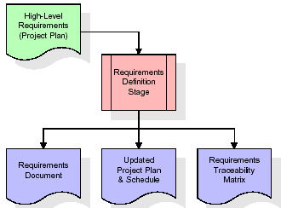
These requirements are fully described in the primary deliverables for this stage: the Requirements Document and the Requirements Traceability Matrix (RTM). The requirements document contains complete descriptions of each requirement, including diagrams and references to external documents as necessary. Note that detailed listings of database tables and fields are not included in the requirements document.
The title of each requirement is also placed into the first version of the RTM, along with the title of each goal from the project plan. The purpose of the RTM is to show that the product components developed during each stage of the software development lifecycle are formally connected to the components developed in prior stages.
In the requirements stage, the RTM consists of a list of high-level requirements, or goals, by title, with a listing of associated requirements for each goal, listed by requirement title. In this hierarchical listing, the RTM shows that each requirement developed during this stage is formally linked to a specific product goal. In this format, each requirement can be traced to a specific product goal, hence the term requirements traceability.
The outputs of the requirements definition stage include the requirements document, the RTM, and an updated project plan.
- Feasibility study is all about identification of problems in a project.
- No. of staff required to handle a project is represented as Team Formation, in this case only modules are individual tasks will be assigned to employees who are working for that project.
- Project Specifications are all about representing of various possible inputs submitting to the server and corresponding outputs along with reports maintained by administrator.
Analysis Stage:
The planning stage establishes a bird's eye view of the intended software product, and uses this to establish the basic project structure, evaluate feasibility and risks associated with the project, and describe appropriate management and technical approaches.
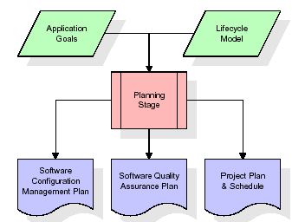
The most critical section of the project plan is a listing of high-level product requirements, also referred to as goals. All of the software product requirements to be developed during the requirements definition stage flow from one or more of these goals. The minimum information for each goal consists of a title and textual description, although additional information and references to external documents may be included. The outputs of the project planning stage are the configuration management plan, the quality assurance plan, and the project plan and schedule, with a detailed listing of scheduled activities for the upcoming Requirements stage, and high level estimates of effort for the out stages.
Designing Stage:
The design stage takes as its initial input the requirements identified in the approved requirements document. For each requirement, a set of one or more design elements will be produced as a result of interviews, workshops, and/or prototype efforts. Design elements describe the desired software features in detail, and generally include functional hierarchy diagrams, screen layout diagrams, tables of business rules, business process diagrams, pseudo code, and a complete entity-relationship diagram with a full data dictionary. These design elements are intended to describe the software in sufficient detail that skilled programmers may develop the software with minimal additional input.

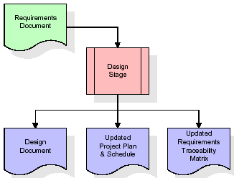
When the design document is finalized and accepted, the RTM is updated to show that each design element is formally associated with a specific requirement. The outputs of the design stage are the design document, an updated RTM, and an updated project plan.
Development (Coding) Stage:
The development stage takes as its primary input the design elements described in the approved design document. For each design element, a set of one or more software artefacts will be produced. Software artefacts include but are not limited to menus, dialogs, and data management forms, data reporting formats, and specialized procedures and functions. Appropriate test cases will be developed for each set of functionally related software artefacts, and an online help system will be developed to guide users in their interactions with the software.
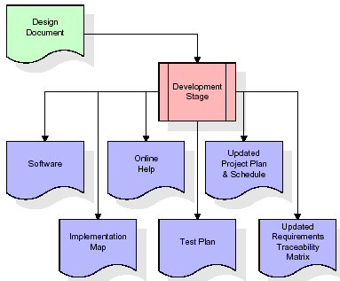

The RTM will be updated to show that each developed artefact is linked to a specific design element, and that each developed artefact has one or more corresponding test case items. At this point, the RTM is in its final configuration. The outputs of the development stage include a fully functional set of software that satisfies the requirements and design elements previously documented, an online help system that describes the operation of the software, an implementation map that identifies the primary code entry points for all major system functions, a test plan that describes the test cases to be used to validate the correctness and completeness of the software, an updated RTM, and an updated project plan.
Integration & Test Stage:
During the integration and test stage, the software artefacts, online help, and test data are migrated from the development environment to a separate test environment. At this point, all test cases are run to verify the correctness and completeness of the software. Successful execution of the test suite confirms a robust and complete migration capability. During this stage, reference data is finalized for production use and production users are identified and linked to their appropriate roles. The final reference data (or links to reference data source files) and production user list are compiled into the Production Initiation Plan.
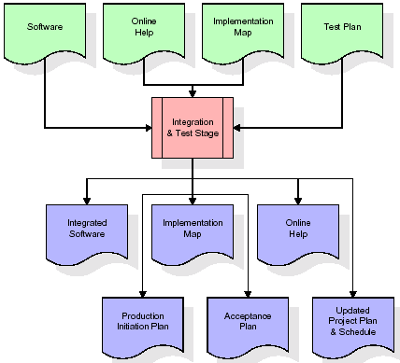
The outputs of the integration and test stage include an integrated set of software, an online help system, an implementation map, a production initiation plan that describes reference data and production users, an acceptance plan which contains the final suite of test cases, and an updated project plan.
- Installation & Acceptance Test:
During the installation and acceptance stage, the software artefacts, online help, and initial production data are loaded onto the production server. At this point, all test cases are run to verify the correctness and completeness of the software. Successful execution of the test suite is a prerequisite to acceptance of the software by the customer.
After customer personnel have verified that the initial production data load is correct and the test suite has been executed with satisfactory results, the customer formally accepts the delivery of the software.
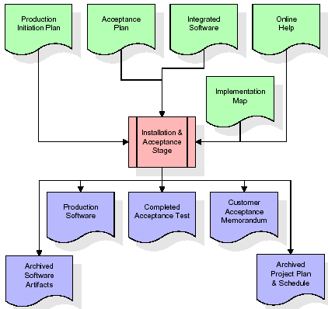
The primary outputs of the installation and acceptance stage include a production application, a completed acceptance test suite, and a memorandum of customer acceptance of the software. Finally, the PDR enters the last of the actual labor data into the project schedule and locks the project as a permanent project record. At this point the PDR "locks" the project by archiving all software items, the implementation map, the source code, and the documentation for future reference.
Maintenance:
Outer rectangle represents maintenance of a project, Maintenance team will start with requirement study, understanding of documentation later employees will be assigned work and they will undergo training on that particular assigned category. For this life cycle there is no end, it will be continued so on like an umbrella (no ending point to umbrella sticks).
3.4. Software Requirement Specification
3.4.1. Overall Description
A Software Requirements Specification (SRS) – a requirements specification for a software system is a complete description of the behaviour of a system to be developed. It includes a set of use cases that describe all the interactions the users will have with the software. In addition to use cases, the SRS also contains non-functional requirements. Non-functional requirements are requirements which impose constraints on the design or implementation (such as performance engineering requirements, quality standards, or design constraints).
System requirements specification: A structured collection of information that embodies the requirements of a system. A business analyst, sometimes titled system analyst, is responsible for analyzing the business needs of their clients and stakeholders to help identify business problems and propose solutions. Within the systems development lifecycle domain, the BA typically performs a liaison function between the business side of an enterprise and the information technology department or external service providers. Projects are subject to three sorts of requirements:
- Business requirements describe in business terms what must be delivered or accomplished to provide value.
- Product requirements describe properties of a system or product (which could be one of several ways to accomplish a set of business requirements.)
- Process requirements describe activities performed by the developing organization. For instance, process requirements could specify .Preliminary investigation examine project feasibility, the likelihood the system will be useful to the organization. The main objective of the feasibility study is to test the Technical, Operational and Economical feasibility for adding new modules and debugging old running system. All system is feasible if they are unlimited resources and infinite time. There are aspects in the feasibility study portion of the preliminary investigation:

- ECONOMIC FEASIBILITY
A system can be developed technically and that will be used if installed must still be a good investment for the organization. In the economical feasibility, the development cost in creating the system is evaluated against the ultimate benefit derived from the new systems. Financial benefits must equal or exceed the costs. The system is economically feasible. It does not require any addition hardware or software. Since the interface for this system is developed using the existing resources and technologies available at NIC, There is nominal expenditure and economical feasibility for certain.
- Operational Feasibility
Proposed projects are beneficial only if they can be turned out into information system. That will meet the organization’s operating requirements. Operational feasibility aspects of the project are to be taken as an important part of the project implementation. This system is targeted to be in accordance with the above-mentioned issues. Beforehand, the management issues and user requirements have been taken into consideration. So there is no question of resistance from the users that can undermine the possible application benefits. The well-planned design would ensure the optimal utilization of the computer resources and would help in the improvement of performance status.
- TECHNICAL FEASIBILITY
Earlier no system existed to cater to the needs of ‘Secure Infrastructure Implementation System’. The current system developed is technically feasible. It is a web based user interface for audit workflow at NIC-CSD. Thus it provides an easy access to .the users. The database’s purpose is to create, establish and maintain a workflow among various entities in order to facilitate all concerned users in their various capacities or roles. Permission to the users would be granted based on the roles specified. Therefore, it provides the technical guarantee of accuracy, reliability and security.

3.4.2. External Interface Requirements
User Interface
The user interface of this system is a user friendly python Graphical User Interface.
Hardware Interfaces
The interaction between the user and the console is achieved through python capabilities.
Software Interfaces
The required software is python.
HARDWARE REQUIREMENTS:

Processor - Intel I3(min)
- Speed - 1.1 Ghz
- RAM - 4GB(min)
- Hard Disk - 500GB(min)
- Key Board - Standard Windows Keyboard
- Mouse - Two or Three Button Mouse
- Monitor - SVGA
SOFTWARE REQUIREMENTS:
- Operating System - Windows10/above
- Programming Language - Python 3.7/above
4. SYSTEM DESIGN
UML Diagram:
The Unified Modelling Language allows the software engineer to express an analysis model using the modelling notation that is governed by a set of syntactic semantic and pragmatic rules.
A UML system is represented using five different views that describe the system from distinctly different perspective. Each view is defined by a set of diagram, which is as follows.
  - User Model View
    - This view represents the system from the users perspective.
    - The analysis representation describes a usage scenario from the end-users perspective.
  - Structural Model view
    - In this model the data and functionality are arrived from inside the system.
    - This model view models the static structures.
- Behavioural Model View
It represents the dynamic of behavioural as parts of the system, depicting the interactions of collection between various structural elements described in the user model and structural model view.
- Implementation Model View
In this the structural and behavioural as parts of the system are represented as they are to be built.
- Environmental Model View
In this the structural and behavioural aspects of the environment in which the system is to be implemented are represented.

Class Diagram:
The class diagram is the main building block of object oriented modeling. It is used both for general conceptual modeling of the systematic of the application, and for detailed modeling translating the models into programming code. Class diagrams can also be used for data modeling. The classes in a class diagram represent both the main objects, interactions in the application and the classes to be programmed. In the diagram, classes are represented with boxes which contain three parts:
- The upper part holds the name of the class
- The middle part contains the attributes of the class
- The bottom part gives the methods or operations the class can take or undertake

Use case Diagram:
A use case diagram at its simplest is a representation of a user's interaction with the system and depicting the specifications of a use case. A use case diagram can portray the different types of users of a system and the various ways that they interact with the system. This type of diagram is typically used in conjunction with the textual use case and will often be accompanied by other types of diagrams as well.

Sequence diagram:
A sequence diagram is a kind of interaction diagram that shows how processes operate with one another and in what order. It is a construct of a Message Sequence Chart. A sequence diagram shows object interactions arranged in time sequence. It depicts the objects and classes involved in the scenario and the sequence of messages exchanged between the objects needed to carry out the functionality of the scenario. Sequence diagrams are typically associated with use case realizations in the Logical View of the system under development. Sequence diagrams are sometimes called event diagrams, event scenarios, and timing diagrams.

Collaboration diagram:
A collaboration diagram describes interactions among objects in terms of sequenced messages. Collaboration diagrams represent a combination of information taken from class, sequence, and use case diagrams describing both the static structure and dynamic behaviour of a system.

Component Diagram:
In the Unified Modelling Language, a component diagram depicts how components are wired together to form larger components and or software systems. They are used to illustrate the structure of arbitrarily complex systems.
Components are wired together by using an assembly connector to connect the required interface of one component with the provided interface of another component. This illustrates the service consumer - service provider relationship between the two components.

Deployment Diagram:
A deployment diagram in the Unified Modeling Language models the physical deployment of artifacts on nodes. To describe a web site, for example, a deployment diagram would show what hardware components ("nodes") exist (e.g., a web server, an application server, and a database server), what software components ("artifacts") run on each node (e.g., web application, database), and how the different pieces are connected (e.g. JDBC, REST, RMI).
The nodes appear as boxes, and the artifacts allocated to each node appear as rectangles within the boxes. Nodes may have sub nodes, which appear as nested boxes. A single node in a deployment diagram may conceptually represent multiple physical nodes, such as a cluster of database servers.

Activity Diagram:
Activity diagram is another important diagram in UML to describe dynamic aspects of the system. It is basically a flow chart to represent the flow form one activity to another activity. The activity can be described as an operation of the system. So the control flow is drawn from one operation to another. This flow can be sequential, branched or concurrent
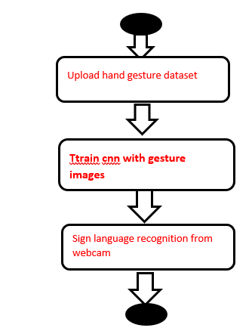

Data Flow Diagram:
Data flow diagrams illustrate how data is processed by a system in terms of inputs and outputs. Data flow diagrams can be used to provide a clear representation of any business function. The technique starts with an overall picture of the business and continues by analyzing each of the functional areas of interest. This analysis can be carried out in precisely the level of detail required. The technique exploits a method called top-down expansion to conduct the analysis in a targeted way.

As the name suggests, Data Flow Diagram (DFD) is an illustration that explicates the passage of information in a process. A DFD can be easily drawn using simple symbols. Additionally, complicated processes can be easily automated by creating DFDs using easy-to-use, free downloadable diagramming tools. A DFD is a model for constructing and analyzing information processes. DFD illustrates the flow of information in a process depending upon the inputs and outputs. A DFD can also be referred to as a Process Model. A DFD demonstrates business or technical process with the support of the outside data saved, plus the data flowing from the process to another and the end results.
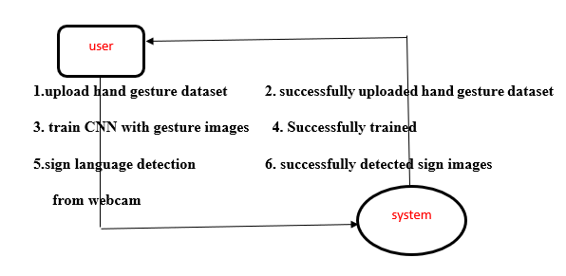

5. IMPLEMETATION
5.1 Python
Python is a general-purpose language. It has wide range of applications from Web development (like: Django and Bottle), scientific and mathematical computing (Orange, SymPy, NumPy) to desktop graphical user Interfaces (Pygame, Panda3D). The syntax of the language is clean and length of the code is relatively short. It's fun to work in Python because it allows you to think about the problem rather than focusing on the syntax.
History of Python:
Python is a fairly old language created by Guido Van Rossum. The design began in the late 1980s and was first released in February 1991.
Why Python was created?
In late 1980s, Guido Van Rossum was working on the Amoeba distributed operating system group. He wanted to use an interpreted language like ABC (ABC has simple easy-to-understand syntax) that could access the Amoeba system calls. So, he decided to create a language that was extensible. This led to design of a new language which was later named Python.
Why the name Python?
No. It wasn't named after a dangerous snake. Rossum was fan of a comedy series from late seventies. The name "Python" was adopted from the same series "Monty Python's Flying Circus".
Features of Python:
A simple language which is easier to learn
Python has a very simple and elegant syntax. It's much easier to read and write Python programs compared to other languages like: C++, Java, C#. Python makes programming fun and allows you to focus on the solution rather than syntax.
If you are a newbie, it's a great choice to start your journey with Python.
Free and open-source
You can freely use and distribute Python, even for commercial use. Not only can you use and distribute software’s written in it, you can even make changes to the Python's source code.
Python has a large community constantly improving it in each iteration.
Portability
You can move Python programs from one platform to another, and run it without any changes.
It runs seamlessly on almost all platforms including Windows, Mac OS X and Linux.
Extensible and Embeddable
Suppose an application requires high performance. You can easily combine pieces of C/C++ or other languages with Python code.
This will give your application high performance as well as scripting capabilities which other languages may not provide out of the box.
A high-level, interpreted language
Unlike C/C++, you don't have to worry about daunting tasks like memory management, garbage collection and so on.
Likewise, when you run Python code, it automatically converts your code to the language your computer understands. You don't need to worry about any lower-level operations.
Large standard libraries to solve common tasks
Python has a number of standard libraries which makes life of a programmer much easier since you don't have to write all the code yourself. For example: Need to connect MySQL database on a Web server? You can use MySQLdb library using import MySQLdb .
Standard libraries in Python are well tested and used by hundreds of people. So you can be sure that it won't break your application.
Object-oriented
Everything in Python is an object. Object oriented programming (OOP) helps you solve a complex problem intuitively.
With OOP, you are able to divide these complex problems into smaller sets by creating objects.
Applications of Python:
1. Simple Elegant Syntax
Programming in Python is fun. It's easier to understand and write Python code. Why? The syntax feels natural. Take this source code for an example:
a = 2
b = 3
sum = a + b
print(sum)
2. Not overly strict
You don't need to define the type of a variable in Python. Also, it's not necessary to add semicolon at the end of the statement.
Python enforces you to follow good practices (like proper indentation). These small things can make learning much easier for beginners.
3. Expressiveness of the language
Python allows you to write programs having greater functionality with fewer lines of code. Here's a link to the source code of Tic-tac-toe game with a graphical interface and a smart computer opponent in less than 500 lines of code. This is just an example. You will be amazed how much you can do with Python once you learn the basics.
4. Great Community and Support
Python has a large supporting community. There are numerous active forums online which can be handy if you are stuck.

5.2 Sample Code:
from tkinter import messagebox
from tkinter import *
from tkinter import simpledialog
import tkinter
from tkinter import filedialog
from tkinter.filedialog import askopenfilename
import cv2
import random
import numpy as np
from keras.utils.np_utils import to_categorical
from keras.layers import MaxPooling2D
from keras.layers import Dense, Dropout, Activation, Flatten
from keras.layers import Convolution2D
from keras.models import Sequential
from keras.models import model_from_json
import pickle
import os
import imutils
from gtts import gTTS
from playsound import playsound
import os
from threading import Thread

main = tkinter.Tk()
main.title("Sign Language Recognition to Text & Voice using CNN Advance")
main.geometry("1300x1200")

global filename
global classifier

bg = None
playcount = 0

#names = ['Palm','I','Fist','Fist Moved','Thumbs up','Index','OK','Palm Moved','C','Down']
names = ['C','Thumbs Down','Fist','I','Ok','Palm','Thumbs up']

def getID(name):
index = 0
for i in range(len(names)):
if names[i] == name:
index = i
break
return index

bgModel = cv2.createBackgroundSubtractorMOG2(0, 50)

def deleteDirectory():
filelist = [ f for f in os.listdir('play') if f.endswith(".mp3") ]
for f in filelist:
os.remove(os.path.join('play', f))

def play(playcount,gesture):
class PlayThread(Thread):
def __init__(self,playcount,gesture):
Thread.__init__(self)
self.gesture = gesture
self.playcount = playcount

def run(self):
t1 = gTTS(text=self.gesture, lang='en', slow=False)
t1.save("play/"+str(self.playcount)+".mp3")
playsound("play/"+str(self.playcount)+".mp3")

newthread = PlayThread(playcount,gesture)
newthread.start()

def remove_background(frame):
fgmask = bgModel.apply(frame, learningRate=0)
kernel = np.ones((3, 3), np.uint8)
fgmask = cv2.erode(fgmask, kernel, iterations=1)
res = cv2.bitwise_and(frame, frame, mask=fgmask)
return res

def uploadDataset():
global filename
global labels
labels = []
filename = filedialog.askdirectory(initialdir=".")
pathlabel.config(text=filename)
text.delete('1.0', END)
text.insert(END,filename+" loaded\n\n");

def trainCNN():
global classifier
text.delete('1.0', END)
X_train = np.load('model1/X.txt.npy')
Y_train = np.load('model1/Y.txt.npy')
text.insert(END,"CNN is training on total images : "+str(len(X_train))+"\n")

if os.path.exists('model1/model.json'):
with open('model1/model.json', "r") as json_file:
loaded_model_json = json_file.read()
classifier = model_from_json(loaded_model_json)
classifier.load_weights("model1/model_weights.h5")
classifier._make_predict_function()
print(classifier.summary())
f = open('model1/history.pckl', 'rb')
data = pickle.load(f)
f.close()
acc = data['accuracy']
accuracy = acc[9] * 100
text.insert(END,"CNN Hand Gesture Training Model Prediction Accuracy = "+str(accuracy))
else:
classifier = Sequential()
classifier.add(Convolution2D(32, 3, 3, input_shape = (64, 64, 3), activation = 'relu'))
classifier.add(MaxPooling2D(pool_size = (2, 2)))
classifier.add(Convolution2D(32, 3, 3, activation = 'relu'))
classifier.add(MaxPooling2D(pool_size = (2, 2)))
classifier.add(Flatten())
classifier.add(Dense(output_dim = 256, activation = 'relu'))
classifier.add(Dense(output_dim = 5, activation = 'softmax'))
print(classifier.summary())
classifier.compile(optimizer = 'adam', loss = 'categorical_crossentropy', metrics = ['accuracy'])
hist = classifier.fit(X_train, Y_train, batch_size=16, epochs=10, shuffle=True, verbose=2)
classifier.save_weights('model1/model_weights.h5')
model_json = classifier.to_json()
with open("model1/model.json", "w") as json_file:
json_file.write(model_json)
f = open('model1/history.pckl', 'wb')
pickle.dump(hist.history, f)
f.close()
f = open('model1/history.pckl', 'rb')
data = pickle.load(f)
f.close()
acc = data['accuracy']
accuracy = acc[9] * 100
text.insert(END,"CNN Hand Gesture Training Model Prediction Accuracy = "+str(accuracy))

def run_avg(image, aWeight):
global bg
if bg is None:
bg = image.copy().astype("float")
return
cv2.accumulateWeighted(image, bg, aWeight)

def segment(image, threshold=25):
global bg
diff = cv2.absdiff(bg.astype("uint8"), image)
thresholded = cv2.threshold(diff, threshold, 255, cv2.THRESH_BINARY)[1]
( cnts, _) = cv2.findContours(thresholded.copy(), cv2.RETR_EXTERNAL, cv2.CHAIN_APPROX_SIMPLE)
if len(cnts) == 0:
return
else:
segmented = max(cnts, key=cv2.contourArea)
return (thresholded, segmented)

def webcamPredict():
global playcount
oldresult = 'none'
count = 0
fgbg2 = cv2.createBackgroundSubtractorKNN();
aWeight = 0.5
camera = cv2.VideoCapture(0)
top, right, bottom, left = 10, 350, 325, 690
num_frames = 0
while(True):
(grabbed, frame) = camera.read()
frame = imutils.resize(frame, width=700)
frame = cv2.flip(frame, 1)
clone = frame.copy()
(height, width) = frame.shape[:2]
roi = frame[top:bottom, right:left]
gray = cv2.cvtColor(roi, cv2.COLOR_BGR2GRAY)
gray = cv2.GaussianBlur(gray, (41, 41), 0)
if num_frames < 30:
run_avg(gray, aWeight)
else:
temp = gray
hand = segment(gray)
if hand is not None:
(thresholded, segmented) = hand
cv2.drawContours(clone, [segmented + (right, top)], -1, (0, 0, 255))
#cv2.imwrite("test.jpg",temp)
#cv2.imshow("Thesholded", temp)
#ret, thresh = cv2.threshold(temp, 150, 255, cv2.THRESH_BINARY + cv2.THRESH_OTSU)
#thresh = cv2.resize(thresh, (64, 64))
#thresh = np.array(thresh)
#img = np.stack((thresh,)*3, axis=-1)
roi = frame[top:bottom, right:left]
roi = fgbg2.apply(roi);
cv2.imwrite("test.jpg",roi)
#cv2.imwrite("newDataset/Fist/"+str(count)+".png",roi)
#count = count + 1
#print(count)
img = cv2.imread("test.jpg")
img = cv2.resize(img, (64, 64))
img = img.reshape(1, 64, 64, 3)
img = np.array(img, dtype='float32')
img /= 255
predict = classifier.predict(img)
value = np.amax(predict)
cl = np.argmax(predict)
result = names[np.argmax(predict)]
if value >= 0.99:
print(str(value)+" "+str(result))
cv2.putText(clone, 'Gesture Recognize as : '+str(result), (10, 25), cv2.FONT_HERSHEY_SIMPLEX,0.5, (0, 255, 255), 2)
if oldresult != result:
play(playcount,result)
oldresult = result
playcount = playcount + 1
else:
cv2.putText(clone, '', (10, 25), cv2.FONT_HERSHEY_SIMPLEX,0.5, (0, 255, 255), 2)
cv2.imshow("video frame", roi)
cv2.rectangle(clone, (left, top), (right, bottom), (0,255,0), 2)
num_frames += 1
cv2.imshow("Video Feed", clone)
keypress = cv2.waitKey(1) & 0xFF
if keypress == ord("q"):
break
camera.release()
cv2.destroyAllWindows()

font = ('times', 16, 'bold')
title = Label(main, text='Sign Language Recognition to Text & Voice using CNN Advance',anchor=W, justify=CENTER)
title.config(bg='yellow4', fg='white')
title.config(font=font)
title.config(height=3, width=120)
title.place(x=0,y=5)

font1 = ('times', 13, 'bold')
upload = Button(main, text="Upload Hand Gesture Dataset", command=uploadDataset)
upload.place(x=50,y=100)
upload.config(font=font1)

pathlabel = Label(main)
pathlabel.config(bg='yellow4', fg='white')
pathlabel.config(font=font1)
pathlabel.place(x=50,y=150)

markovButton = Button(main, text="Train CNN with Gesture Images", command=trainCNN)
markovButton.place(x=50,y=200)
markovButton.config(font=font1)

predictButton = Button(main, text="Sign Language Recognition from Webcam", command=webcamPredict)
predictButton.place(x=50,y=250)
predictButton.config(font=font1)

font1 = ('times', 12, 'bold')
text=Text(main,height=15,width=78)
scroll=Scrollbar(text)
text.configure(yscrollcommand=scroll.set)
text.place(x=450,y=100)
text.config(font=font1)

deleteDirectory()
main.config(bg='magenta3')
main.mainloop()

6. TESTING
Implementation and Testing:
Implementation is one of the most important tasks in project is the phase in which one has to be cautions because all the efforts undertaken during the project will be very interactive. Implementation is the most crucial stage in achieving successful system and giving the users confidence that the new system is workable and effective. Each program is tested individually at the time of development using the sample data and has verified that these programs link together in the way specified in the program specification. The computer system and its environment are tested to the satisfaction of the user.

Implementation

The implementation phase is less creative than system design. It is primarily concerned with user training, and file conversion. The system may be requiring extensive user training. The initial parameters of the system should be modifies as a result of a programming. A simple operating procedure is provided so that the user can understand the different functions clearly and quickly. The different reports can be obtained either on the inkjet or dot matrix printer, which is available at the disposal of the user. The proposed system is very easy to implement. In general implementation is used to mean the process of converting a new or revised system design into an operational one.

Testing
Testing is the process where the test data is prepared and is used for testing the modules individually and later the validation given for the fields. Then the system testing takes place which makes sure that all components of the system property functions as a unit. The test data should be chosen such that it passed through all possible condition. Actually testing is the state of implementation which aimed at ensuring that the system works accurately and efficiently before the actual operation commence. The following is the description of the testing strategies, which were carried out during the testing period.

System Testing
Testing has become an integral part of any system or project especially in the field of information technology. The importance of testing is a method of justifying, if one is ready to move further, be it to be check if one is capable to with stand the rigors of a particular situation cannot be underplayed and that is why testing before development is so critical. When the software is developed before it is given to user to use the software must be tested whether it is solving the purpose for which it is developed. This testing involves various types through which one can ensure the software is reliable. The program was tested logically and pattern of execution of the program for a set of data are repeated. Thus the code was exhaustively checked for all possible correct data and the outcomes were also checked.
Module Testing
To locate errors, each module is tested individually. This enables us to detect error and correct it without affecting any other modules. Whenever the program is not satisfying the required function, it must be corrected to get the required result. Thus all the modules are individually tested from bottom up starting with the smallest and lowest modules and proceeding to the next level. Each module in the system is tested separately. For example the job classification module is tested separately. This module is tested with different job and its approximate execution time and the result of the test is compared with the results that are prepared manually. The comparison shows that the results proposed system works efficiently than the existing system. Each module in the system is tested separately. In this system the resource classification and job scheduling modules are tested separately and their corresponding results are obtained which reduces the process waiting time.
Integration Testing
After the module testing, the integration testing is applied. When linking the modules there may be chance for errors to occur, these errors are corrected by using this testing. In this system all modules are connected and tested. The testing results are very correct. Thus the mapping of jobs with resources is done correctly by the system.
Acceptance Testing
When that user fined no major problems with its accuracy, the system passers through a final acceptance test. This test confirms that the system needs the original goals, objectives and requirements established during analysis without actual execution which elimination wastage of time and money acceptance tests on the shoulders of users and management, it is finally acceptable and ready for the operation.
TESTCASES:

7. SCREENSHOTS
In this project using CNN we are recognizing hand gesture movement and to train CNN we are using following images shown in below screen shots
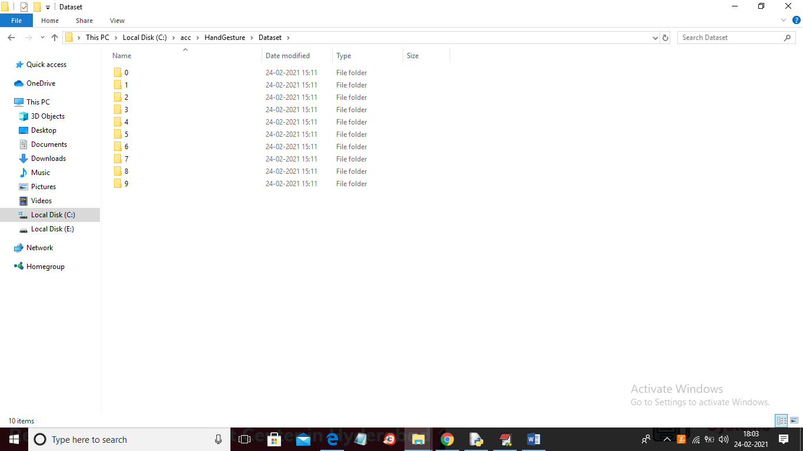
In above screen we can see we have 10 different types of hand gesture images and to see those images just go inside any folder
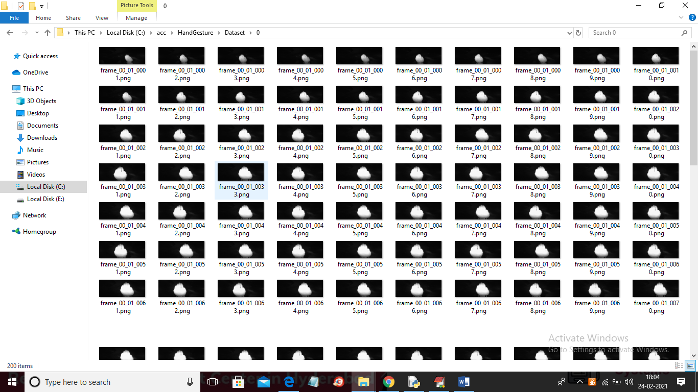
In above screen showing images from 0 folder and similarly you can see different images in different folders.
SCREEN SHOTS
To run project double click on run.bat file to get below screen
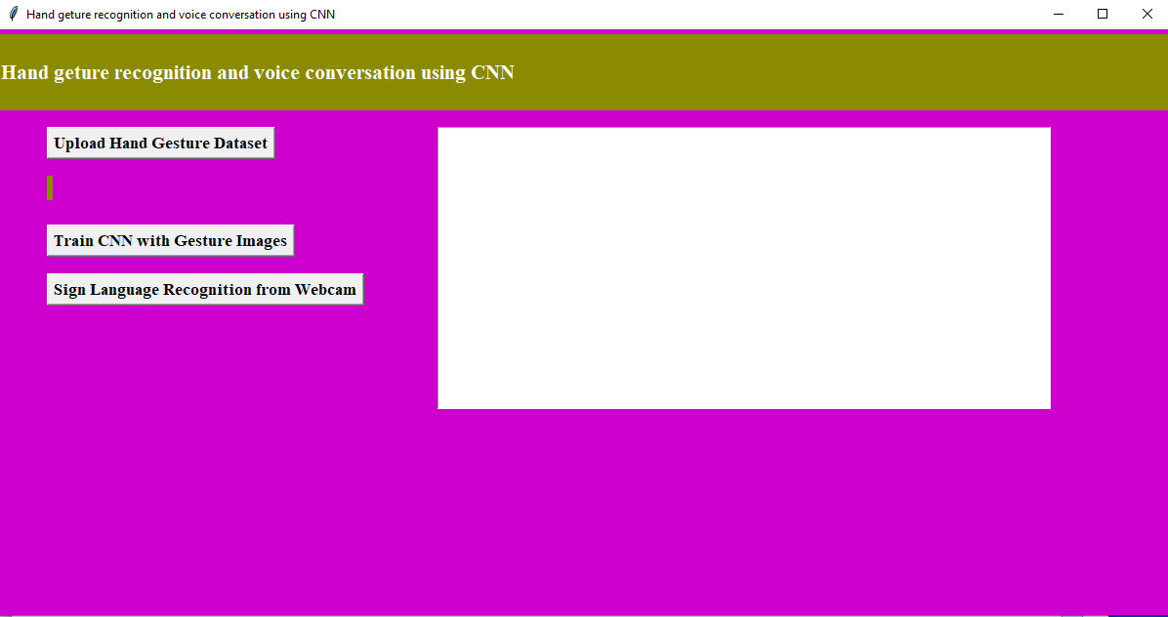
In above screen click on ‘Upload Hand Gesture Dataset’ button to upload dataset and to get below screen
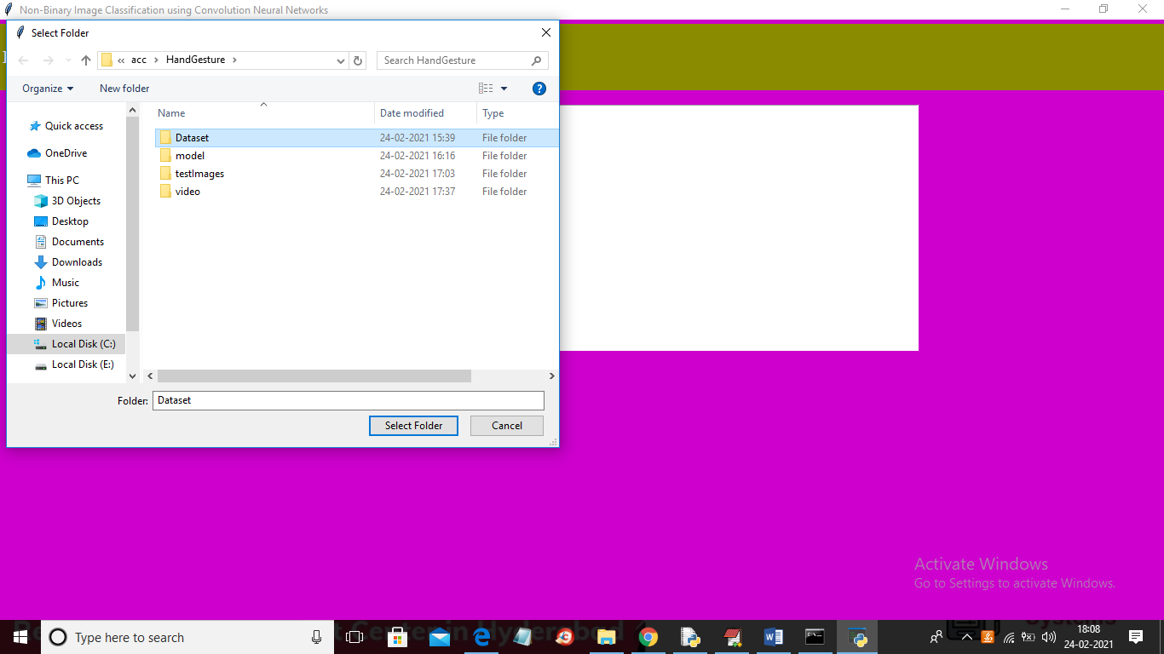
In above screen selecting and uploading ‘Dataset’ folder and then click on ‘Select Folder’ button to load dataset and to get below screen
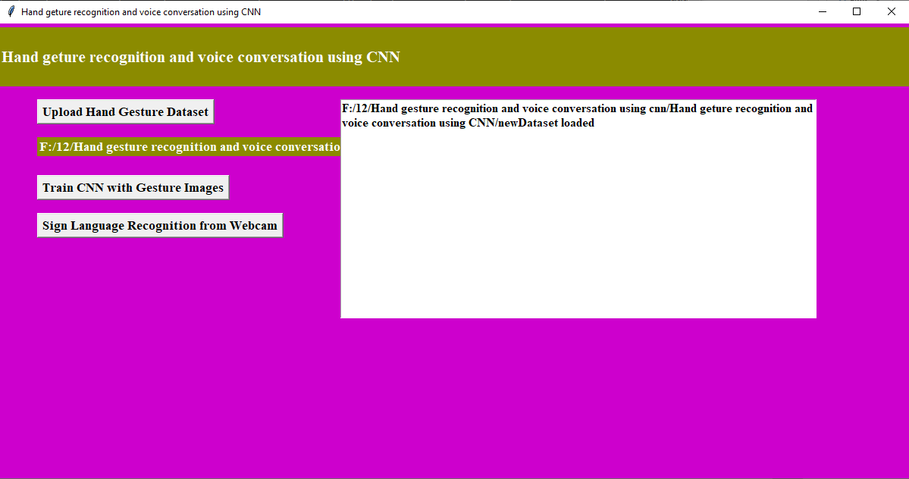
In above screen dataset loaded and now click on ‘Train CNN with Gesture Images’ button to trained CNN model and to get below screen
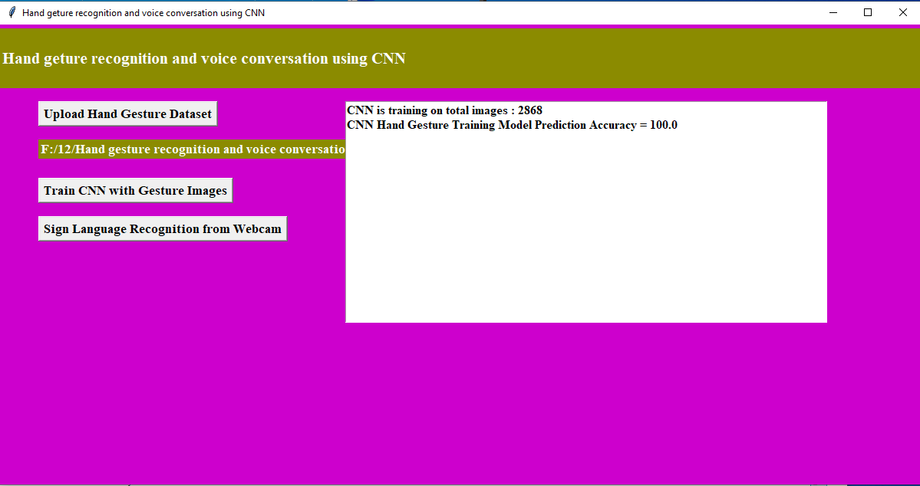
In above screen CNN model trained on 2000 images and its prediction accuracy we got as 100% and now model is ready and now click on ‘Upload Test Image & Recognize Gesture’ button to upload image and to gesture recognition
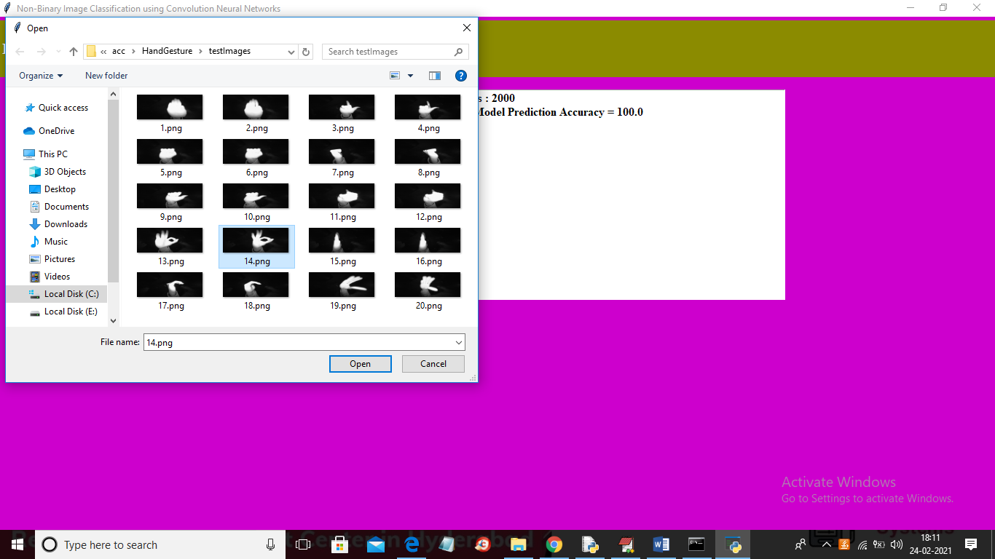
In above screen selecting and uploading ’14.png’ file and then click Open button to get below result
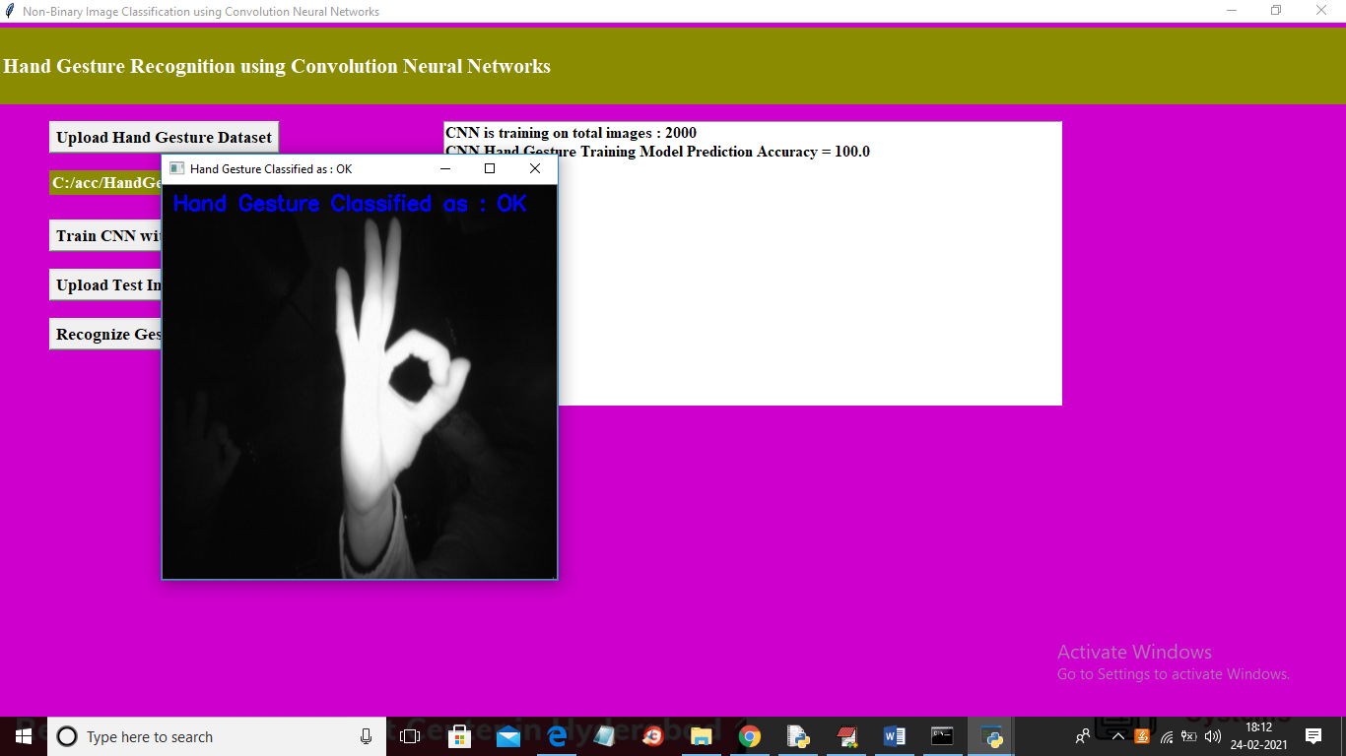
In above screen gesture recognize as OK and similarly you can upload any image and get result and now click on ‘Recognize Gesture from Video’ button to upload video and get result
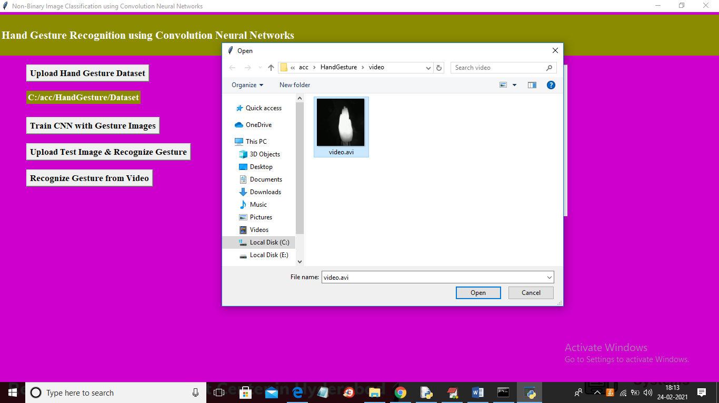
In above screen selecting and uploading ‘video.avi’ file and then click on ‘Open’ button to get below result
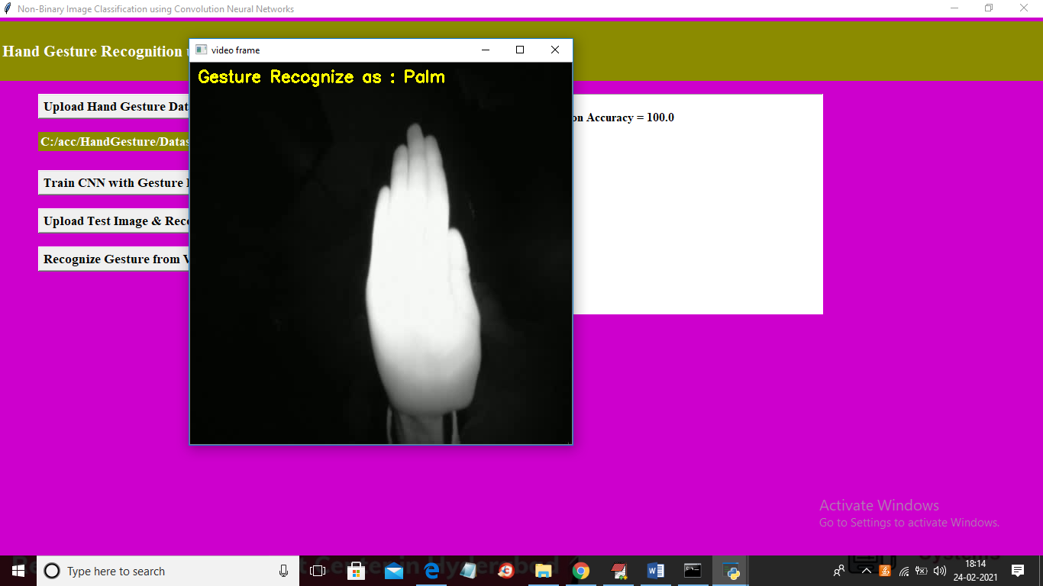
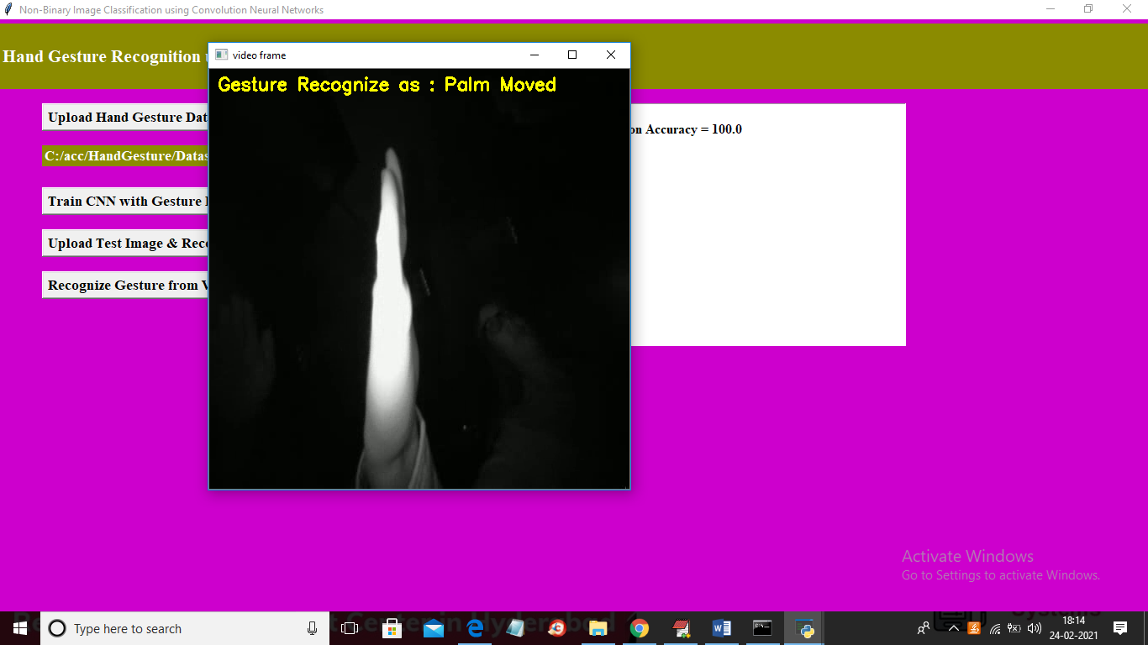
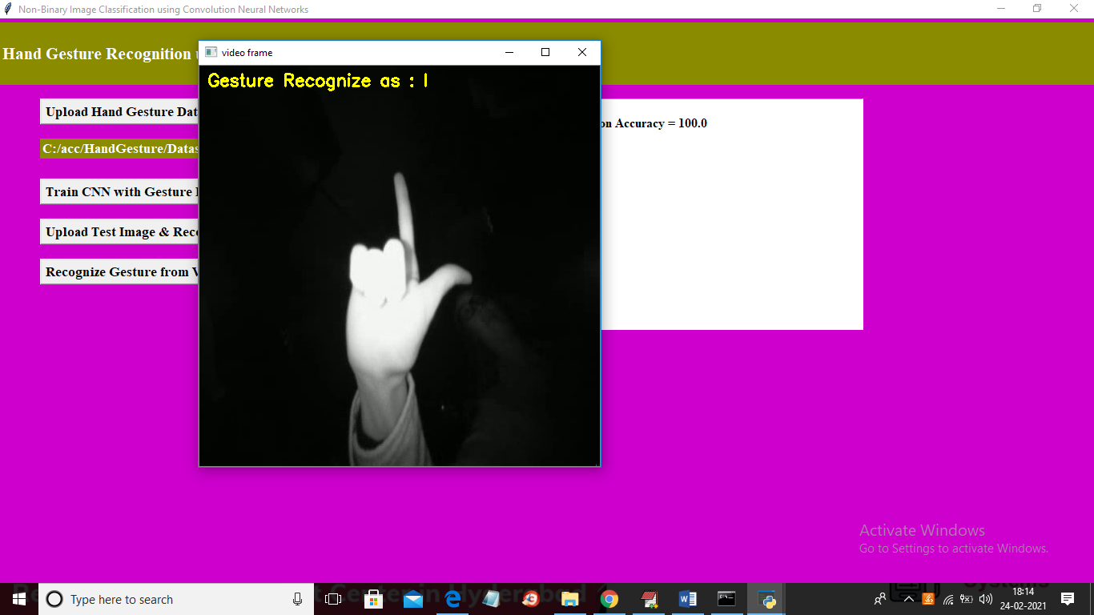
In above screen as video play then will get recognition result
CONCLUSION
We developed a CNN model for sign language recognition. Our model learns and extracts both spatial and temporal features by performing 3D convolutions. The developed deep architecture extracts multiple types of information from adjacent input frames and then performs convolution and subsampling separately. The final feature representation combines information from all channels. We use multilayer perceptron classifier to classify these feature representations. For comparison, we evaluate both CNN and GMM-HMM on the same dataset. The experimental results demonstrate the effectiveness of the proposed method.
REFERENCES
[1] Shinde, Shweta S., Rajesh M. Autee, and Vitthal K. Bhosale. "Real time two way communication approach for hearing impaired and dumb person based on image processing." Computational Intelligence and Computing Research (ICCIC), 2016 IEEE International Conference on. IEEE, 2016.
[2] Shangeetha, R. K., V. Valliammai, and S. Padmavathi. "Computer vision based approach for Indian Sign Language character recognition." Machine Vision and Image Processing (MVIP), 2012 International Conference on. IEEE, 2012.
[3] Sood, Anchal, and Anju Mishra. "AAWAAZ: A communication system for deaf and dumb." Reliability, Infocom Technologies and Optimization (Trends and Future Directions)(ICRITO), 2016 5th International Conference on. IEEE, 2016.
[4] Ahire, Prashant G., et al. "Two Way Communicator between Deaf and Dumb People and Normal People." Computing Communication Control and Automation (ICCUBEA), 2015 International Conference on. IEEE, 2015.
[5] Ms R. Vinitha and Ms A. Theerthana. "Design And Development Of Hand GestureRecognition System For Speech Impaired People."
[6] Kumari, Sonal, and Suman K. Mitra. "Human action recognition using DFT." Computer Vision, Pattern Recognition, Image Processing and Graphics (NCVPRIPG), 2011 Third National Conference on. IEEE, 2011.

